**MEHAK RAFIQ**

BS I ZOOLOGY

**1ST ASSIGNMENT OF ENVIRONMENTAL SCIENCE**

SUBMITED TO

**MISS ERUM**

TOPIC:

AYUBIA NATIONAL PARK..

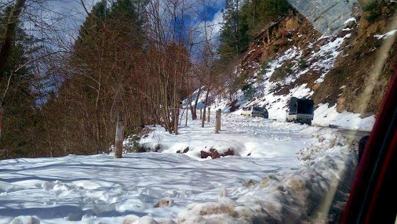

# :*Ayubia national park:*

## Introduction:

Ayubia National Park (Urdu: ایوبیہ نیشنل پارک‎) (shortened as Ayubia (Urdu: ایوبیہ‎)) is a protected area of 3,312 hectares (8,184 acres) located in Abbottabad District, Khyber Pakhtunkhwa province, northern Pakistan. It was declared a national park in 1984. Ayubia was named after Muhammad Ayub Khan (1958–1969), second President of Pakistan. The area supports temperate coniferous forest and temperate broadleaf and mixed forest ecoregion habitats, with an average elevation of 8,000 feet (2,400 m) above the sea level.

Ayubia National Park is surrounded by seven major villages and four small towns of Thandiani, Nathiagali, Ayubia and Khanspur. The park has been developed as a resort complex from a combination of four mini resorts of Khaira Gali, Changla Gali, Khanspur and Ghora Dhaka in Galyat. Currently, it is manageHistory

Ayubia National Park was established in 1984 in an east corner of Khyber Pakhtunkhwa, province of Pakistan. In 1998 it was expanded form its original size of 1,684 hectares (4,161 acres) or 16.84 km2 (6.50 sq mi) to 3,312 hectares (8,184 acres). Since then it has been managed by the Khyber Pakhtunkhwa Wildlife Department. The purpose of establishing it was to conserve the temperate forests. Originally, the park stood at an area of 857 acres (3.47 km2), but in 1998 it was expanded to cover an area of 1,685 acres (6.82 km2).The total population of Ayubia and surrounding villages as per a 1996 census is18,097 living in 2,311 households.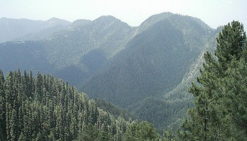

## Climate:

Track in Ayubia

The climate of the park is cold in the summers, but harsh in the winters. While it remains only placidly hot in May and June, the cold sets in when the monsoons come to lash in late July and early August. In the winters cold increases in severity gradually until the west winds bring rains, which eventually turn into snow. The park remains snow-capped through the later part of winters.

Rainfall: 1,244 cm

Temperature: 3 °C - 11 °C

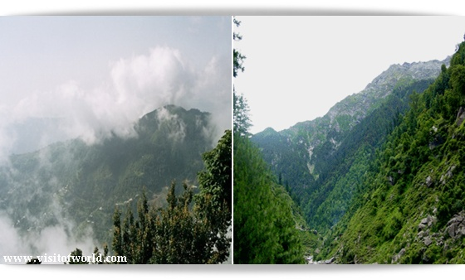

Wildlife:

A panoramic view of Tilla Donga

The park holds 104 species of plants. The main floral species are Cedrus deodara, blue pine, yew, silver fir, horse chestnut and oak. Around 21 plants belonging to 19 families are known for their medicinal properties. Many of these are used in treatment of jaundice, stomach ulcers, snake bites, internal infections, diabetes, psoriasis and more. Some plants are said to have anti-caricogenic effect as well. Also, some are used as biological insecticides and pesticides, mostly due to their insect-repellant nature. The World Wide Fund for Nature has launched an ethno-botanical initiative here "to demonstrate the sustainable use of plant resources as a means for protecting biodiversity."

The park harbors up to 203 species of birds. Many species of birds, including the golden eagle, the vulture, Eurasian sparrowhawk and the hill pigeon among others can be found here. It is also home to some of the rarer Himalayan pheasant species like the kalij and koklass pheasants. Ayubia National Park supports 31 species of mammals. Animals such as the Asiatic leopard, hill fox and flying squirrel can be found here.

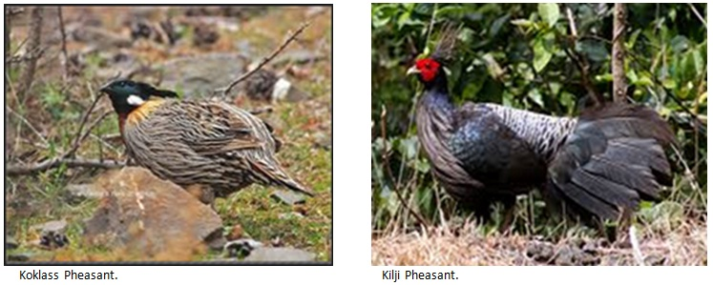

Management:

The park has been managed by Khyber Pakhtunkhwa Wildlife Department under the 1975 Khyber Pakhtunkhwa Wildlife Act. The headquarters of the park is at Dunga Gali, which is situated at a distance of 34 km from Abbottabad and 30 km from Murree.National Park started from the behind of Ayubia Chair lift. In National Park walk track near about distance 4 km from Ayubia Chair lift to Dong Gali. There are many beautiful places. It is also sitting arrange on the way when you start from walk Ayubia to Donga Gali in the National Park.

Tourism

Standing at some 26 kilometers from the tourist hotbed of Murree Hill Station, over 100,000 tourists flock to Ayubia National Park and the places around every year. It is well known for its picnic spots.

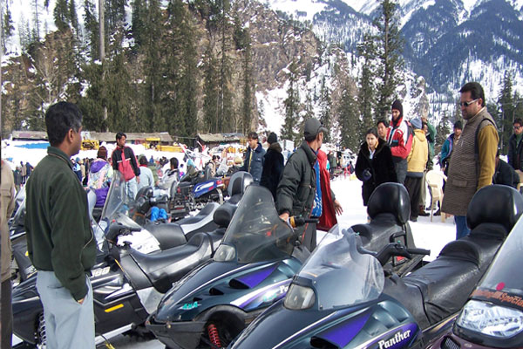

Since there are 7 villages and 4 major towns around it, and since this area attracts a very large number of tourists annually, there is a large number of hotels and restaurants around the park. In addition to riding trails, hiking places, picnic spots and motels, there is a chairlift in the central place of Ayubia that takes the tourists to a nearby summit for a view of the forested hills. This chairlift was the first recreation facility of its kind in Pakistan and is still a major attraction for domestic tourists. The famous PTDC motel is located here.d by the Wildlife and Parks Department of Government of Khyber Pakhtunkhwa.

Darwaza Ayubia

Darwaza is a village near Ayubia, situated in the Abbottabad district Union Council Palak, Khyber Pakhtunkhwa, Pakistan. The population of Darwaza is about 5000.

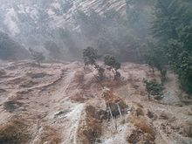

Chamb is a small Mohalla of Village Darwaza which is at a distance of about 2 km from Kuza Gali. Chamb is linked to main Ayubia/[Nathia Gali Road through a link Road from Khaira Gali, Jandala to Darwaza. The population of Chamb is around 1000 and the main places of Chamb are Butti, Kohri, Purana Chamb, Upper Chamb and Lower Chamb. Chamb is considered to be one of the most literate area of Village Darwaza although there is no school in Chamb. About 60 percent of the population of Chamb is associated with hotel industry. Chamb consists of two main Clans—Totyals and Terwals. Totyals are about 80 percent of the population of Chamb.

Ander Kote is a village near Riyali with a population of about 1000 people. There is a primary school in Ander Kote for boys. Main Clans of Ander Kote are Nayyal and Hajyals.

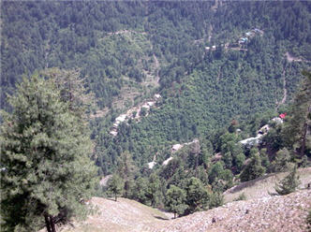

Bagla is a mohalla near Jandala with deobandi Sunni Majority population. Bagla is situated very close to Madrassa Wali Dukhtaran-e-Islam Academy Panyali. Bagla is on the way of Khaira Gali Darwaza Road.

Bantan is considered to be the main hub or in other words, the capital of Darwaza. The population of Bantan is less than 1000 people but this mohalla is very much known for sectarian and political fighting and tussles.

About Ayubia

Four small hill resorts close to one another, Khanspur, Khaira Gali, Changla Gali and Ghora Dhaka are called Ayubia. It was named after the late Muhammad Ayub Khan (1958–1969), second President of Pakistan. The small town is spread over an area of 26 km. The central hill station of Ghjora Dhaka has a chairlift, provided broad charming view of the surroundings. It is littered with hotels and food outlets serving snacks, food, tea and coffee along with other eatables.

